Practical No. 13

Name : Danish Altaf Solkar | Class : CO - B
Enrolment no. : 24111590805 | Batch : 2

Aim : 3) Design the micro-animation for Status Notification
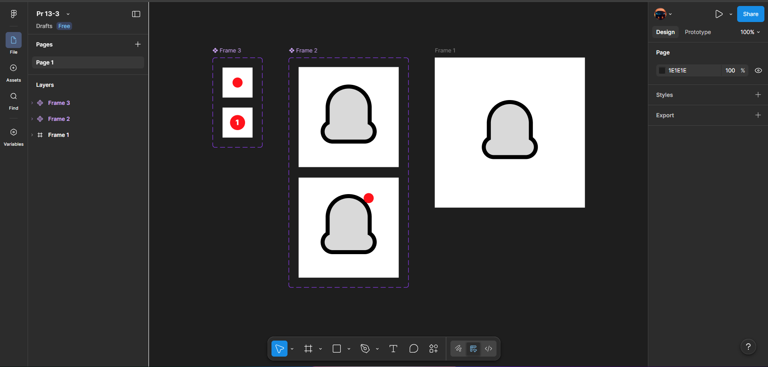


Aim : 4) Design the micro-animation for Button Click Feedback
